Dr. Su Jin Jez
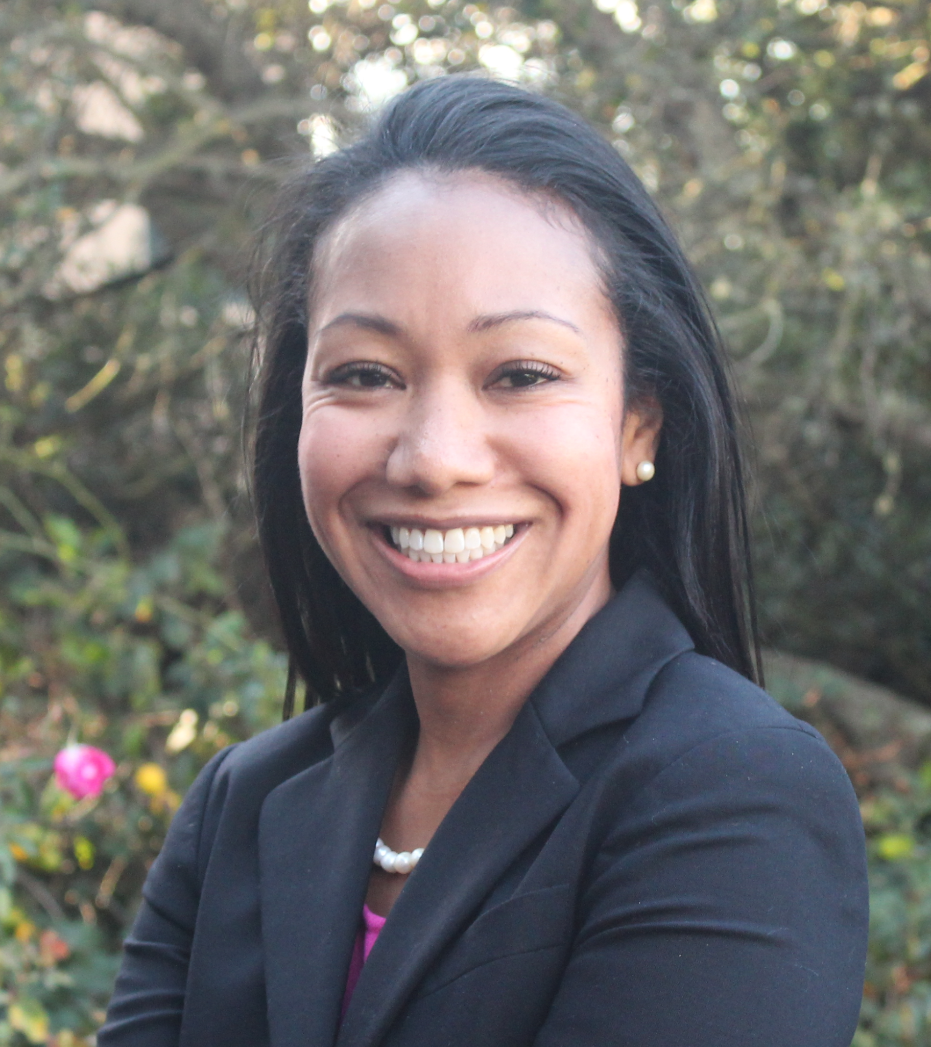
As CEO of California Competes, Dr. Su Jin Jez leads the organization’s work to develop nonpartisan and financially pragmatic recommendations for improved higher education and workforce policies and practices across California.

Prior to joining California Competes, she spent over a decade as a professor of Public Policy and Administration at California State University, Sacramento. In this role, she also held positions as Director of the CSU Student Success Network, Academic Advisor for the California Executive Fellows Program, and Associate Director of the Sacramento State Doctorate in Educational Leadership.

Su Jin is an accomplished researcher who has been widely published in leading academic journals and provides guidance to California’s higher education institutions and leadership through her applied research. She presents across the country and internationally on key issues in higher education and systems change, including economic and workforce development, college readiness and success, student college choice and decision-making, and institutional effectiveness.

In recognition of her contributions to transforming higher education to meet the needs of today's society, economy, and diverse student population, Dr. Jez received Stanford University’s Graduate School of Education’s highest alumni distinction, the 2023 Stanford Alumni Excellence in Education Award. Additionally, the Council for Adult and Experiential Learning (CAEL) honored Dr. Jez with the 2021 Pamela Tate Rise Award for her leadership in advancing policy solutions that expand working adults’ access to higher education and economic mobility.

She currently serves on the following boards and councils: California's Cradle-to-Career Data System Governing Board, Credential Engine’s Board of Directors, Tipping Point Community’s Leadership Council, the Every Learner Everywhere Equity Advisory Board, the Campaign for College Opportunity's Policy Research Advisory Board, and the West Contra Costa Unified School District's Local Control Accountability Plan Committee.

She holds a PhD in education administration and policy analysis and an MA in economics from Stanford University. She received a bachelor’s in statistics and a minor in public policy from the University of California, Berkeley.

